TESTING RPEORT
XCROS
Responsive Testing Report – xcros.in
Testing Results
Issues Identified
Mobile S – 320px
- Upper content is cut off and not fully visible.
- Right-side content is not displayed properly.
- Horizontal scrolling is required to view some sections.
Mobile M – 375px
- Upper content is partially cut off.
Mobile L – 425px
- Same upper-content cutoff issue identified.
Tablet – 768px
- Upper content is hidden near the time/status bar area.
4K Display – 2560px
- Content appears too small for the screen size.
- Layout does not fully utilize the available display area.
iPhone SE
- Small portion of upper content is not visible properly.
Galaxy Z Fold 5
- Side content is not displayed correctly in foldable screen view.

Devices Working Properly
Laptop – 1024px
- Website functioning correctly without layout issues.
Laptop L – 1440px
- Fully responsive and properly aligned.
iPhone XR
- All content displayed correctly.
Asus Zenbook Fold
- Responsive layout working properly.
Samsung Galaxy A51 / A71
- No responsiveness issues found.
Nest Hub
- Layout displayed correctly.
Nest Hub Max
- Website working properly.

Navigation & Functionality Testing Report – xcros.in
Website: xcros.in
Testing Date: 11 May 2026
Objective
The purpose of this testing was to verify the functionality of navigation menus, links, icons, and internal pages of the website.

Navigation Testing Results
Home Page
- Main navigation and homepage functionalities are working properly.
- Basic page navigation is functioning correctly.

Issues Identified
Privacy & Terms Page
- Privacy Policy and Terms links are not working properly.
- Clicking the links does not open the required page/content.
World Icon / Language Icon
- The world icon symbol is not functioning.
- No action or redirection occurs when clicked.

Beta Version Page
Working Features
- Beta version page opens correctly.
- Basic navigation inside the beta page is working.
QR Code Scanning
- QR code scanning feature opens successfully.
- However, after scanning, the message shows:
  - “Code are deactivated”
- Feature is currently inactive or disabled.

Inside Beta Version – Chat by Admin

The following features/pages are not working properly:
- Notifications
- Submit a Ticket
- Knowledge Base
- Video Tutorials
- Reviews
- Forum
- Webinars
- ChatGPT
- AI
- Whiteboard
Observations
- pages do not open.
- Some buttons are unresponsive.
Inside Beta Version Page – View All Pincodes & view cities
Contact Us → User Legal
Issues Found
Notice Section
- Website links are showing as raw HTML/code instead of proper clickable links.
- HTML tags are visible on the page.
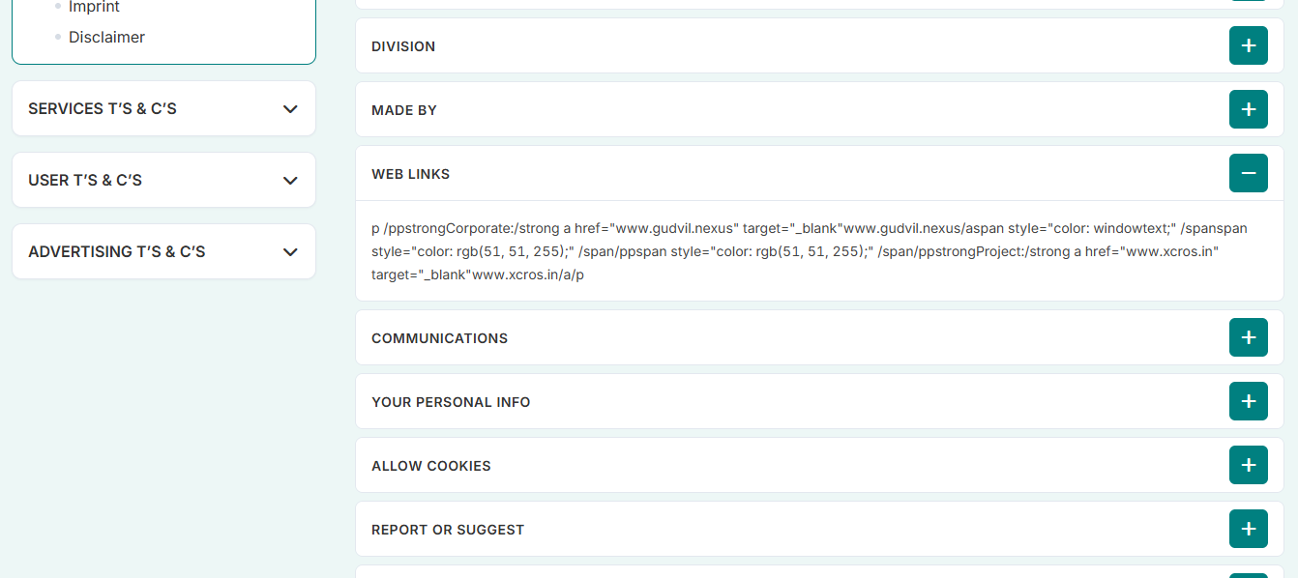
Cookies Section
- “Manage Consent Preference” layout is not aligned properly.
- Radio button UI looks broken/unstructured.
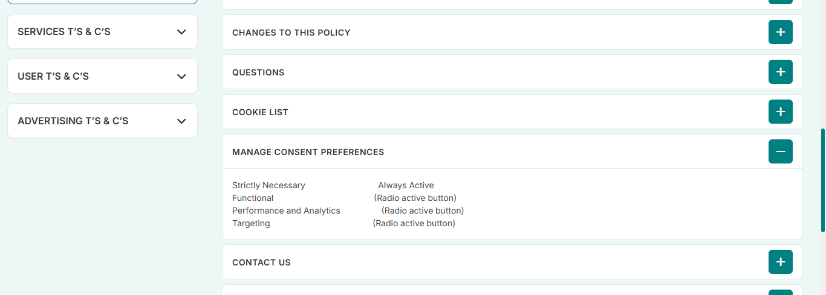
Inside the Beta Version – By city Chennai
Inside the Beta Version page, when selecting the city Chennai,
- in Chennai location launch sponsors some images are not displaying properly.
- Contact US not wokring
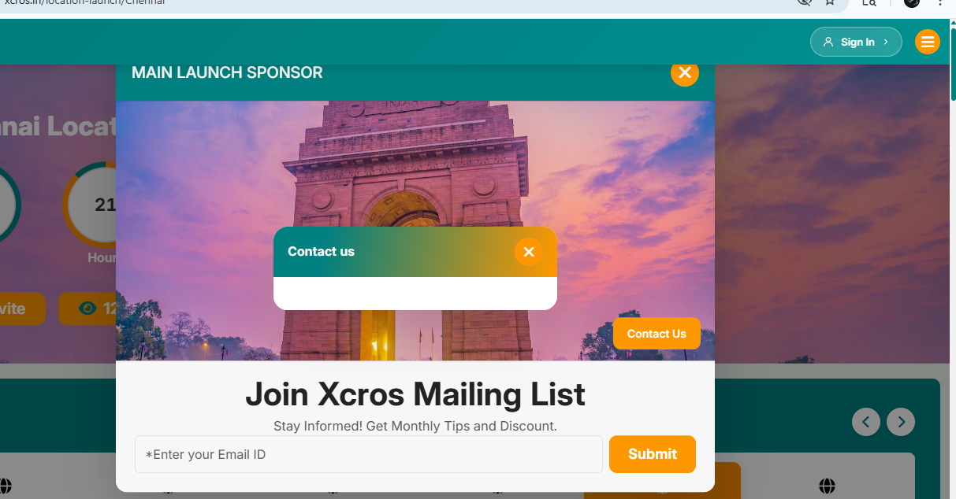

Inside Beta Version Page – View All Pincodes & view cities
Observation
- Some images are not displaying properly.
- Blank image placeholders are visible in certain sections.

Features Listing – Business Page
- The listing “The Grand Spice Kitchen” image is not showing properly.
- Some sort/filter buttons are not functioning correctly.
- Clicking certain sort options gives no response.

Features Listing – Professional Page
- “The Grand Spice Kitchen” image is not displaying.
- “Book an Appointment” button is not working.

Features Listing – Handyman Page
- “The Grand Spice Kitchen” image is missing.
- “Book an Appointment” functionality is not working.

Explore Popular Categories Section
Categories Tested
- Women Fashion
- Sports and Outdoors
- Jewellery
- Real Estate
- Home and Garden
Observation
- “The Grand Spice Kitchen” images are not showing properly in these categories.

Promoted Category Section
Observation
- “The Grand Spice Kitchen” images are not loading/displaying.

Inside the Explore Popular Categories section, when opening promoted listing pages for restaurants, the restaurant jingle feature is not working.
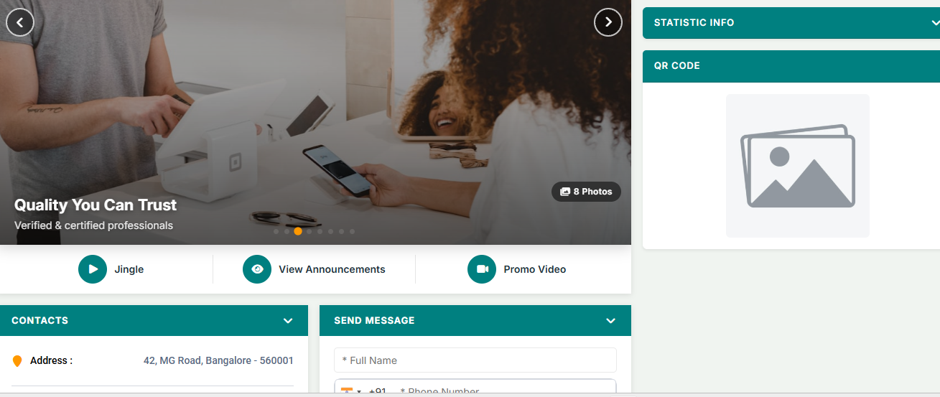

Inside Menu Bar → Support → Help Center
Vertical Services Navigation
- Inside “View by Pincode” and “Connect”, clicking Vertical Services navigates to the wrong page.
- It redirects to Choose Services instead of the Vertical Services page.
Gallery Section
- Add button is not working.
- Images are not displaying properly.
Help Line & Emergency Numbers
- “Get Direction” button is not functioning.
- No navigation or map redirection occurs.
Inside Menu Bar → Support → Help Center → View Profile
Issues Found
Reviews & Service Agents
- Review images are not showing properly.
- Service agent images are missing/not loading.
More Button
- “More” button is not functioning.
- Clicking the button gives no response.
Advertisement Carousel
- Advertisement carousel is not working properly.
- Carousel/slider is not moving or displaying correctly.
Inside Menu Bar → Support → Help Center → Services Marketing
Issue Found
- Search settings dropdown is not working properly.
- Clicking the dropdown gives no response or options are not displayed.
Inside Menu Bar → Support → Help Center → Services Marketing → Stores
Issues Found
Filters Section
- Price range bar is not working properly.
- Slider/filter does not respond correctly.
Images
- Store images are not showing/loading properly.
Inside Menu → About → Careers
Issues Found
Explore Opportunities
- “Explore Opportunities” button/link is not navigating properly.
- Clicking the option gives no response or redirection.
Gudvil-Nexus → Services
- Services page/link is not navigating correctly.
Get Social
- “Get Social” section opens as a blank page.
Inside menu bar -> vertical markets -> expo
- xpo calendar button is not working
Conclusion
The website is functional in several major sections and larger screen devices. However, multiple issues were identified related to:
- Responsive design
- Navigation routing
- Image loading
- Button functionality
- Dropdown/filter operations
- Carousel/jingle functionality
- Internal page redirections

